Task 1

Half subtractor

|  |  |  |  |
| --- | --- | --- | --- |
| X | Y | Difference | Borrow |
| 0 | 0 | 0 | 0 |
| 0 | 1 | 1 | 1 |
| 1 | 0 | 1 | 0 |
| 1 | 1 | 0 | 0 |

Full Subtractor

|  |  |  |  |  |
| --- | --- | --- | --- | --- |
| X | Y | Z(B-in) | Difference | Bout |
| 0 | 0 | 0 | 0 | 0 |
| 0 | 0 | 1 | 1 | 1 |
| 0 | 1 | 0 | 1 | 1 |
| 0 | 1 | 1 | 0 | 1 |
| 1 | 0 | 0 | 1 | 0 |
| 1 | 0 | 1 | 0 | 0 |
| 1 | 1 | 0 | 0 | 0 |
| 1 | 1 | 1 | 1 | 1 |

Task 3

HALF SUBTRACROR

NAND (Difference)

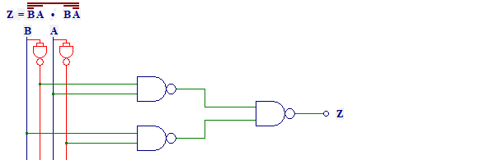

NAND (Borrow)

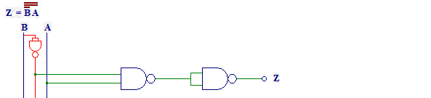

AND-OR (Borrow)

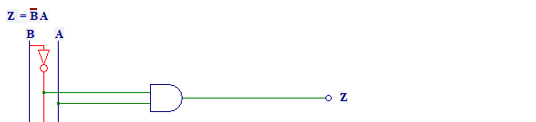

AND-OR (Difference)

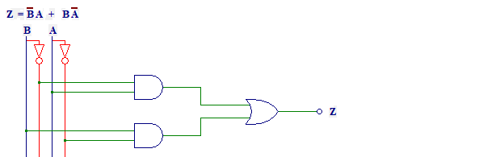

Full Subtractor

NAND

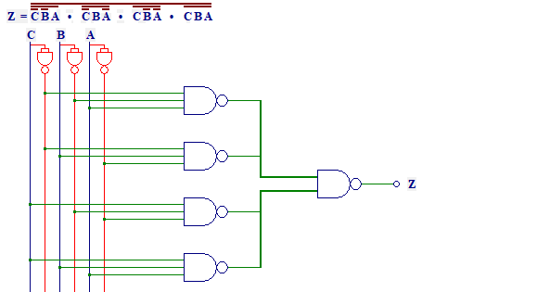

AND-OR

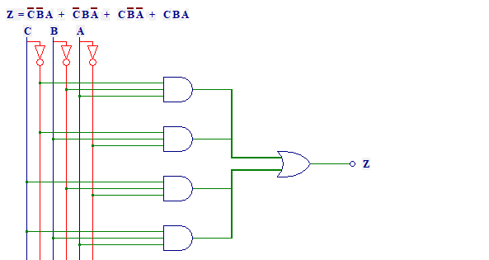

NAND (Borrow)

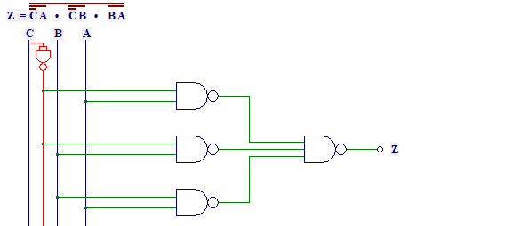

AND-OR (Borrow)

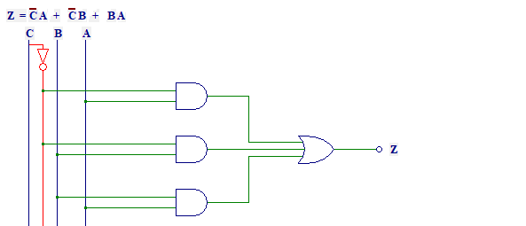

Task 4

Half Subtractor

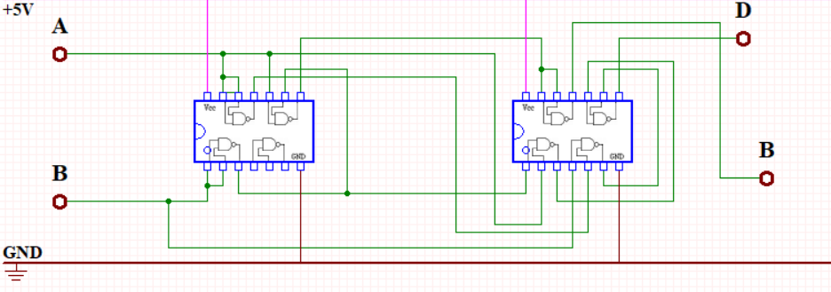

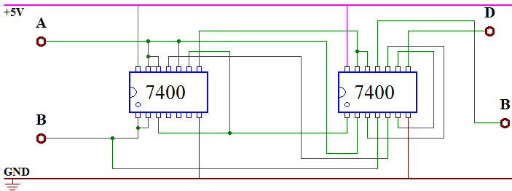

Full Subtractor

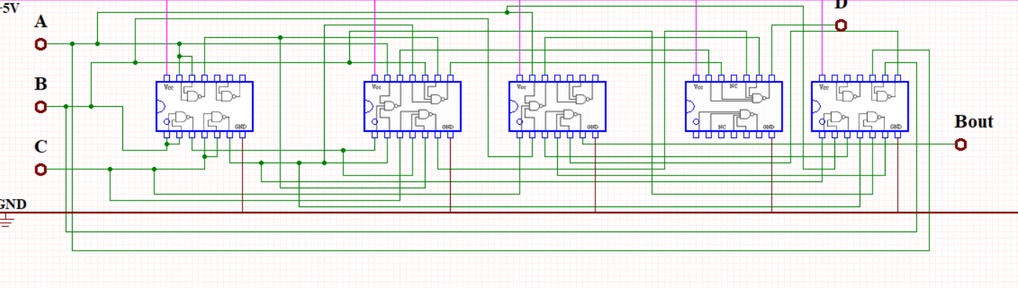

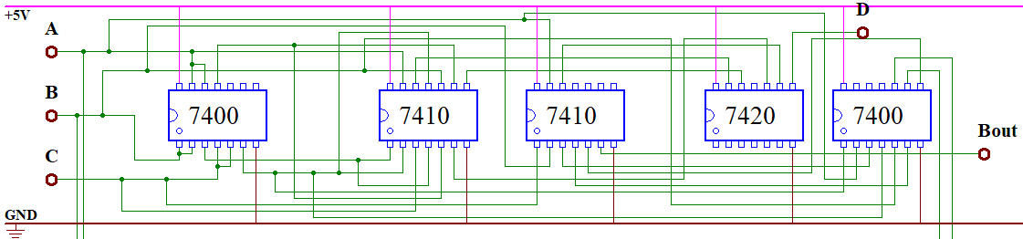

Task 5

Half Sub sim (Difference)

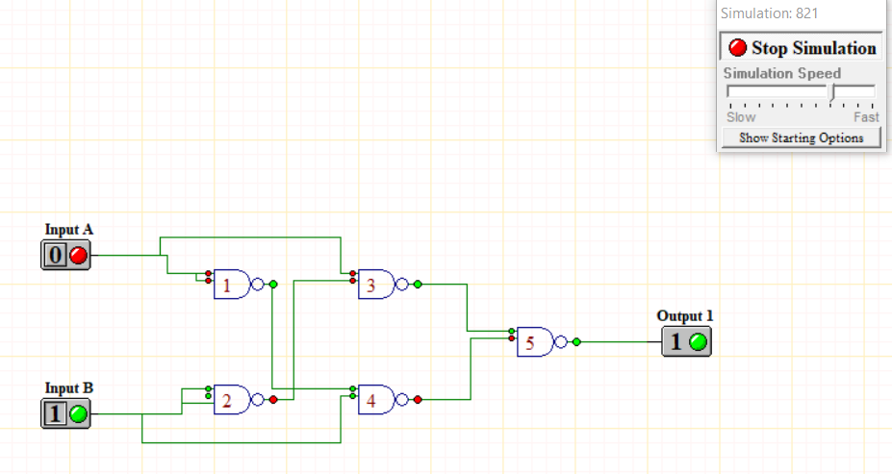

Borrow

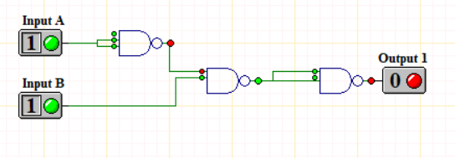

Full sub sim

Difference

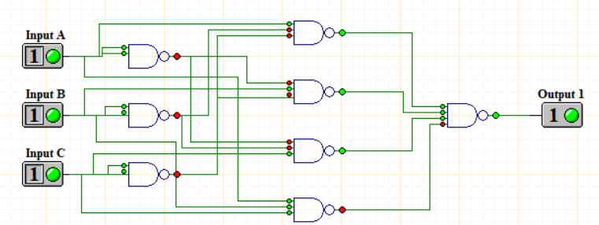

Bout

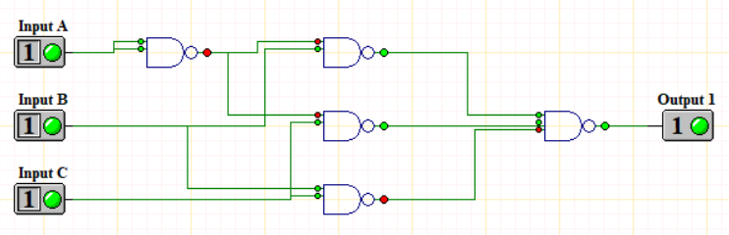

Task 6

